***‘Screams Without Words’: How Hamas Weaponized Sexual Violence on Oct. 7***

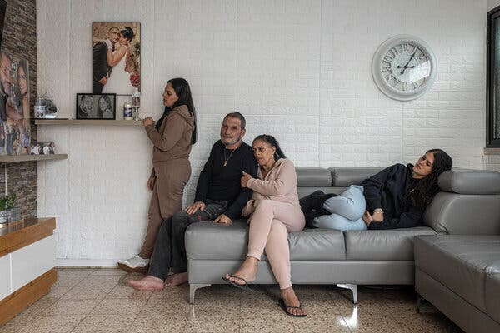

Gal Abdush’s parents, center, and her sisters. The photograph on the wall shows Gal and her husband, Nagi. The couple had been together since they were teenagers.

**By**[**Jeffrey Gettleman**](https://www.nytimes.com/by/jeffrey-gettleman)**, Anat Schwartz and Adam Sella**

**Photographs by Avishag Shaar-Yashuv**

Jeffrey Gettleman, Anat Schwartz and Adam Sella reported from across Israel and interviewed more than 150 people.

* Dec. 28, 2023

At first, she was known simply as “the woman in the black dress.”

In a grainy video, you can see her, lying on her back, dress torn, legs spread, vagina exposed. Her face is burned beyond recognition and her right hand covers her eyes.

The video was shot in the early hours of Oct. 8 by a woman searching for a missing friend at the site of the rave in southern Israel where, the day before, Hamas terrorists [massacred hundreds of young Israelis](https://www.nytimes.com/2023/10/15/world/middleeast/israel-music-festival-massacre.html" \o ").

The video went viral, with thousands of people responding, desperate to know if the woman in the black dress was their missing friend, sister or daughter.

One family knew exactly who she was — Gal Abdush, mother of two from a working-class town in central Israel, who disappeared from the rave that night with her husband.

As the terrorists closed in on her, trapped on a highway in a line of cars of people trying to flee the party, she sent one final WhatsApp message to her family: “You don’t understand.”

Based largely on the video evidence — which was verified by The New York Times — Israeli police officials said they believed that Ms. Abdush was raped, and she has become a symbol of the horrors visited upon Israeli women and girls during the Oct. 7 attacks.

Israeli officials say that everywhere Hamas terrorists struck — the rave, the military bases along the Gaza border and the kibbutzim — they brutalized women.

A two-month investigation by The Times uncovered painful new details, establishing that the attacks against women were not isolated events but part of a broader pattern of gender-based violence on Oct. 7.

Relying on video footage, photographs, GPS data from mobile phones and interviews with more than 150 people, including witnesses, medical personnel, soldiers and rape counselors, The Times identified at least seven locations where Israeli women and girls appear to have been sexually assaulted or mutilated.

By The New York Times

Four witnesses described in graphic detail seeing women raped and killed at two different places along Route 232, the same highway where Ms. Abdush’s half-naked body was found sprawled on the road at a third location.

And The Times interviewed several soldiers and volunteer medics who together described finding more than 30 bodies of women and girls in and around the rave site and in two kibbutzim in a similar state as Ms. Abdush’s — legs spread, clothes torn off, signs of abuse in their genital areas.

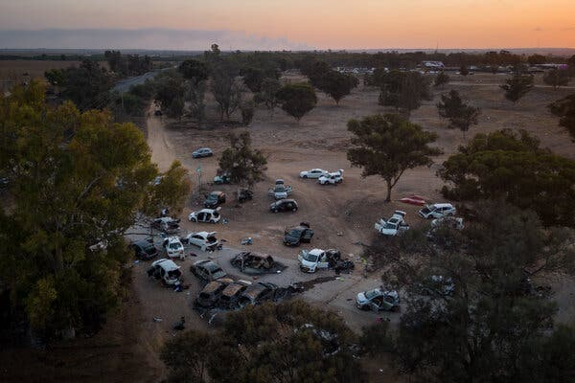

A camp area on Oct. 11 at the rave site in southern Israel.Credit...Sergey Ponomarev for The New York Times

Many of the accounts are difficult to bear, and the visual evidence is disturbing to see.

The Times viewed photographs of one woman’s corpse that emergency responders discovered in the rubble of a besieged kibbutz with dozens of nails driven into her thighs and groin.

The Times also viewed a video, provided by the Israeli military, showing two dead Israeli soldiers at a base near Gaza who appeared to have been shot directly in their vaginas.

Hamas has denied [Israel’s accusations of sexual violence](https://www.nytimes.com/2023/12/04/world/middleeast/israel-hamas-sexual-violence-un.html" \o "). Israeli activists have been outraged that the United Nations Secretary General, António Guterres, and the agency U.N. Women did not [acknowledge the many accusations](https://www.unwomen.org/en/news-stories/statement/2023/12/un-women-statement-on-the-situation-in-israel-and-gaza" \l ":~:text=We%20deeply%20regret%20that%20military,on%20Israel%20on%207%20October." \o "" \t "_blank) until weeks after the attacks.

Investigators with Israel’s top national police unit, Lahav 433, have been steadily gathering evidence but they have not put a number on how many women were raped, saying that most are dead — and buried — and that they will never know. No survivors have spoken publicly.

The Israeli police have acknowledged that, during the shock and confusion of Oct. 7, the deadliest day in Israeli history, they were not focused on collecting semen samples from women’s bodies, requesting autopsies or closely examining crime scenes. At that moment, the authorities said, they were intent on repelling Hamas and identifying the dead.

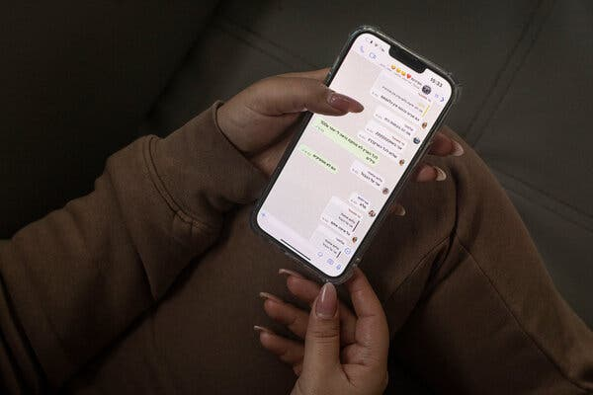

Ms. Abdush’s sister showing one of the last messages Ms. Abdush sent on Oct. 7.

A combination of chaos, enormous grief and Jewish religious duties meant that many bodies were buried as quickly as possible. Most were never examined, and in some cases, like at the rave scene, where more than 360 people were slaughtered in a few hours, the bodies were hauled away by the truckload.

That has left the Israeli authorities at a loss to fully explain to families what happened to their loved ones in their final moments. Ms. Abdush’s relatives, for instance, never received a death certificate. They are still searching for answers.

In cases of widespread sexual violence during a war, it is not unusual to have limited forensic evidence, experts said.

“Armed conflict is so chaotic,” said Adil Haque, a Rutgers law professor and war crimes expert. “People are more focused on their safety than on building a criminal case down the road.”

Very often, he said, sex crime cases will be prosecuted years later on the basis of testimony from victims and witnesses.

“The eyewitness might not even know the name of the victim,” he added. “But if they can testify as, ‘I saw a woman being raped by this armed group,’ that can be enough.”

**‘Screams without words’**

Sapir, a 24-year-old accountant, has become one of the Israeli police’s key witnesses. She does not want to be fully identified, saying she would be hounded for the rest of her life if her last name were revealed.

She attended the rave with several friends and provided investigators with graphic testimony. She also spoke to The Times. In a two-hour interview outside a cafe in southern Israel, she recounted seeing groups of heavily armed gunmen rape and kill at least five women.

She said that at 8 a.m. on Oct. 7, she was hiding under the low branches of a bushy tamarisk tree, just off Route 232, about four miles southwest of the party. She had been shot in the back. She felt faint. She covered herself in dry grass and lay as still as she could.

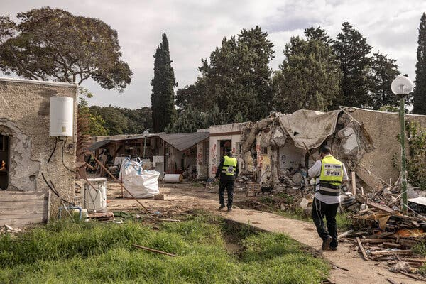

Volunteers with an emergency response team at the Kfar Aza kibbutz this month. The kibbutz was among the places attacked on Oct. 7.

About 15 meters from her hiding place, she said, she saw motorcycles, cars and trucks pulling up. She said that she saw “about 100 men,” most of them dressed in military fatigues and combat boots, a few in dark sweatsuits, getting in and out of the vehicles. She said the men congregated along the road and passed between them assault rifles, grenades, small missiles — and badly wounded women.

“It was like an assembly point,” she said.

The first victim she said she saw was a young woman with copper-color hair, blood running down her back, pants pushed down to her knees. One man pulled her by the hair and made her bend over. Another penetrated her, Sapir said, and every time she flinched, he plunged a knife into her back.

She said she then watched another woman “shredded into pieces.” While one terrorist raped her, she said, another pulled out a box cutter and sliced off her breast.

“One continues to rape her, and the other throws her breast to someone else, and they play with it, throw it, and it falls on the road,” Sapir said.

She said the men sliced her face and then the woman fell out of view. Around the same time, she said, she saw three other women raped and terrorists carrying the severed heads of three more women.

Sapir provided photographs of her hiding place and her wounds, and police officials have stood by her testimony and released a video of her, with her face blurred, recounting some of what she saw.

Yura Karol, a 22-year-old security consultant, said he was hiding in the same spot, and he can be seen in one of Sapir’s photos. He and Sapir were part of a group of friends who had met up at the party. In an interview, Mr. Karol said he barely lifted his head to look at the road but he also described seeing a woman raped and killed.

Since that day, Sapir said, she has struggled with a painful rash that spread across her torso, and she can barely sleep, waking up at night, heart pounding, covered in sweat.

“That day, I became an animal,” she said. “I was emotionally detached, sharp, just the adrenaline of survival. I looked at all this as if I was photographing them with my eyes, not forgetting any detail. I told myself: I should remember everything.”

That same morning, along Route 232 but in a different location about a mile southwest of the party area, Raz Cohen — a young Israeli who had also attended the rave and had worked recently in the Democratic Republic of Congo training Congolese soldiers — said that he was hiding in a dried-up streambed. It provided some cover from the assailants combing the area and shooting anyone they found, he said in an hour-and-a-half interview in a Tel Aviv restaurant.

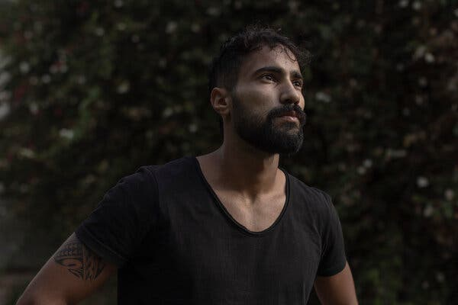

Raz Cohen, a security consultant, survived the Oct. 7 attacks by hiding in a dried-up streambed.

Maybe 40 yards in front of him, he recalled, a white van pulled up and its doors flew open.

He said he then saw five men, wearing civilian clothes, all carrying knives and one carrying a hammer, dragging a woman across the ground. She was young, naked and screaming.

“They all gather around her,” Mr. Cohen said. “She’s standing up. They start raping her. I saw the men standing in a half circle around her. One penetrates her. She screams. I still remember her voice, screams without words.”

“Then one of them raises a knife,” he said, “and they just slaughtered her.”

Shoam Gueta, one of Mr. Cohen’s friends and a fashion designer, said the two were hiding together in the streambed. He said he saw at least four men step out of the van and attack the woman, who ended up “between their legs.” He said that they were “talking, giggling and shouting,” and that one of them stabbed her with a knife repeatedly, “literally butchering her.”

Hours later, the first wave of volunteer emergency medical technicians arrived at the rave site. In interviews, four of them said that they discovered bodies of dead women with their legs spread and underwear missing — some with their hands tied by rope and zipties — in the party area, along the road, in the parking area and in the open fields around the rave site.

Jamal Waraki, a volunteer medic with the nonprofit [ZAKA emergency response team](https://zakaworld.org/?gclid=CjwKCAiAvoqsBhB9EiwA9XTWGRVATzB1Se6-rnlWcrwA9MH2CiFIHkflKzMZSy7K-OhZDQL4mLERZRoCD5YQAvD_BwE" \o "" \t "_blank), said he could not get out of his head a young woman in a rawhide vest found between the main stage and the bar.

“Her hands were tied behind her back,” he said. “She was bent over, half naked, her underwear rolled down below her knees.”

Yinon Rivlin, a member of the rave’s production team who lost two brothers in the attacks, said that after hiding from the killers, he emerged from a ditch and made his way to the parking area, east of the party, along Route 232, looking for survivors.

Near the highway, he said, he found the body of a young woman, on her stomach, no pants or underwear, legs spread apart. He said her vagina area appeared to have been sliced open, “as if someone tore her apart.”

Similar discoveries were made in [two kibbutzim, Be’eri and Kfar Aza](https://www.nytimes.com/2023/12/11/world/middleeast/israel-kibbutz-kfar-aza.html" \o "). Eight volunteer medics and two Israeli soldiers told The Times that in at least six different houses, they had come across a total of at least 24 bodies of women and girls naked or half naked, some mutilated, others tied up, and often alone.

A paramedic in an Israeli commando unit said that he had found the bodies of two teenage girls in a room in Be’eri.

One was lying on her side, he said, boxer shorts ripped, bruises by her groin. The other was sprawled on the floor face down, he said, pajama pants pulled to her knees, bottom exposed, semen smeared on her back.

Because his job was to look for survivors, he said, he kept moving and did not document the scene. Neighbors of the two girls killed — who were sisters, 13 and 16 — said their bodies had been found alone, separated from the rest of their family.

The Israeli military allowed the paramedic to speak with reporters on the condition that he not be identified because he serves in an elite unit.

Many of the dead were brought to the Shura military base, in central Israel, for identification. Here, too, witnesses said they saw signs of sexual violence.

Shari Mendes, an architect called up as a reserve soldier to help prepare the bodies of female soldiers for burial, said she had seen four with signs of sexual violence, including some with “a lot of blood in their pelvic areas.”

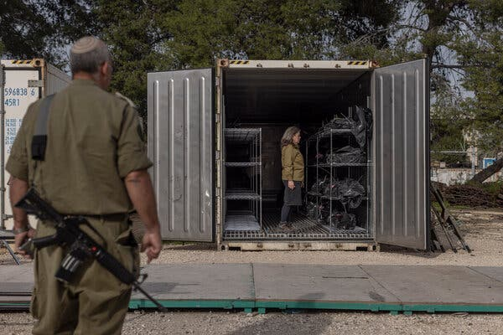

Shari Mendes, an architect who was called up as a reserve soldier to help handle the bodies of female troops, in a container used to hold bodies before their removal to a morgue at the Shura military base in central Israel.

A dentist, Captain Maayan, who worked at the same identification center, said that she had seen at least 10 bodies of female soldiers from Gaza observation posts with signs of sexual violence.

Captain Maayan asked to be identified only by her rank and surname because of the sensitivity of the subject. She said she had seen several bodies with cuts in their vaginas and underwear soaked in blood and one whose fingernails had been pulled out.

**The investigation**

The Israeli authorities have no shortage of video evidence from the Oct. 7 attacks. They have gathered hours of footage from Hamas body cameras, dashcams, security cameras and mobile phones showing Hamas terrorists killing civilians and many images of mutilated bodies.

But Moshe Fintzy, a deputy superintendent and senior spokesman of Israel’s national police, said, “We have zero autopsies, zero,” making an O with his right hand.

In the aftermath of the attack, police officials said, forensic examiners were dispatched to the Shura military base to help identify the hundreds of bodies — Israeli officials say around 1,200 people were killed that day.

The examiners worked quickly to give the agonized families of the missing a sense of closure and to determine, by a process of elimination, who was dead and who was being held hostage in Gaza.

According to Jewish tradition, funerals are held promptly. The result was that many bodies with signs of sexual abuse were put to rest without medical examinations, meaning that potential evidence now lies buried in the ground. International forensic experts said that it would be possible to recover some evidence from the corpses, but that it would be difficult.

Mr. Fintzy said Israeli security forces were still finding imagery that shows women were brutalized. Sitting at his desk at an imposing police building in Jerusalem, he swiped open his phone, tapped and produced the video of the two soldiers shot in the vagina, which he said was recorded by Hamas gunmen and recently recovered by Israeli soldiers.

A colleague sitting next to him, Mirit Ben Mayor, a police chief superintendent, said she believed that the brutality against women was a combination of two ferocious forces, “the hatred for Jews and the hatred for women.”

Some emergency medical workers now wish they had documented more of what they saw. In interviews, they said they had moved bodies, cut off zip ties and cleaned up scenes of carnage. Trying to be respectful to the dead, they inadvertently destroyed evidence.

Many volunteers working for ZAKA, the emergency response team, are religious Jews and operate under strict rules that command deep respect for the dead.

“I did not take pictures because we are not allowed to take pictures,” said Yossi Landau, a ZAKA volunteer. “In retrospect, I regret it.”

There are at least three women and one man who were sexually assaulted and survived, according to Gil Horev, a spokesman for Israel’s Ministry of Welfare and Social Affairs. “None of them has been willing to come physically for treatment,” he said. Two therapists said they were working with a woman who was gang raped at the rave and was in no condition to talk to investigators or reporters.

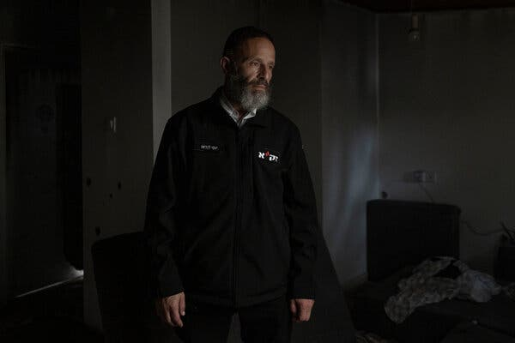

Yossi Landau, a volunteer with the nonprofit ZAKA emergency response team, said he had not taken pictures of the bodies because it was not allowed. “In retrospect, I regret it,” he added.

The trauma from sexual assault can be so heavy that sometimes survivors do not speak about it for years, several rape counselors said.

“Many people are looking for the golden evidence, of a woman who will testify about what happened to her. But don’t look for that, don’t put this pressure on this woman,” said Orit Sulitzeanu, executive director of the Association of Rape Crisis Centers in Israel. “The corpses tell the story.”

**The woman in the black dress**

One of the last images of Ms. Abdush alive — captured by a security camera mounted on her front door — shows her leaving home with her husband, Nagi, at 2:30 a.m. on Oct. 7 for the rave.

He was wearing jeans and a black T-shirt. She was dressed in a short black dress, a black shawl tied around her waist and combat boots. As she struts out, she takes a swig from a glass (her brother-in-law remembers it was Red Bull and vodka) and laughs.

You’ve got to live life like it’s your last moments. That was her motto, her sisters said.

At daybreak, hundreds of terrorists closed in on the party from several directions, blocking the highways leading out. The couple jumped into their Audi, dashing off a string of messages as they moved.

“We’re on the border,” Ms. Abdush wrote to her family. “We’re leaving.”

“Explosions.”

Her husband made his own calls to his family, leaving a final audio message for his brother, Nissim, at 7:44 a.m. “Take care of the kids,” he said. “I love you.”

Gunshots rang out, and the message stopped.

That night, Eden Wessely, a car mechanic, drove to the rave site with three friends and found Ms. Abdush sprawled half naked on the road next to her burned car, about nine miles north of the site. She did not see the body of Mr. Abdush.

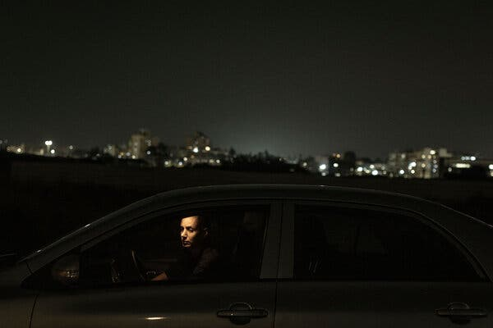

Eden Wessely, a car mechanic, drove to the rave site looking for a missing friend but instead found Ms. Abdush sprawled half naked on the road next to her burned car.

She saw other burned cars and other bodies, and shot videos of several — hoping that they would help people to identify missing relatives. When she posted the video of the woman in the black dress on her Instagram story, she was deluged with messages.

“Hi, based on your description of the woman in the black dress, did she have blonde hair?” one message read.

“Eden, the woman you described with the black dress, do you remember the color of her eyes?” another said.

Some members of the Abdush family saw that video and another version of it filmed by one of Ms. Wessely’s friends. They immediately suspected that the body was Ms. Abdush, and based on the way her body was found, they feared that she might have been raped.

But they kept alive a flicker of hope that somehow, it wasn’t true.

The videos caught the eye of Israeli officials as well — very quickly after Oct. 7 they began gathering evidence of atrocities. They included footage of Ms. Abdush’s body in a presentation made to foreign governments and media organizations, using Ms. Abdush as a representation of violence committed against women that day.

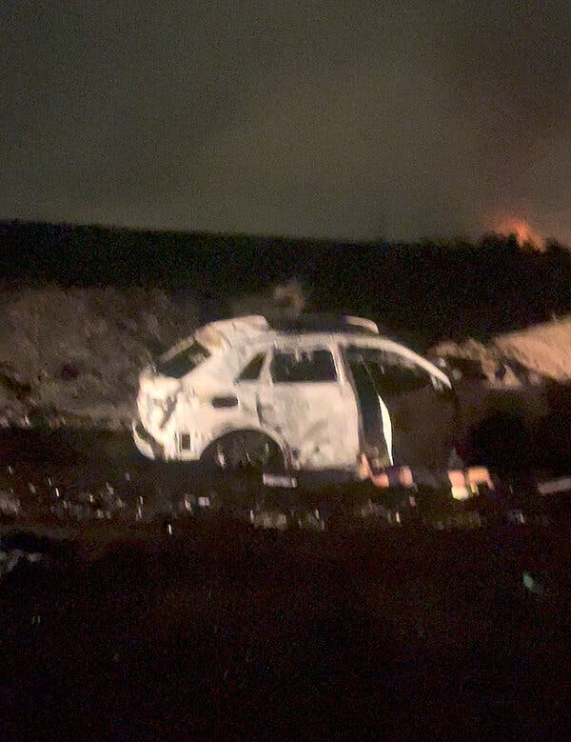

A screenshot from a video showing Ms. Abdush’s body.Credit...Eden Wessely

A week after her body was found, three government social workers appeared at the gate of the family’s home in Kiryat Ekron, a small town in central Israel. They broke the news that Ms. Abdush, 34, had been found dead.

But the only document the family received was a one-page form letter from Israel’s president, Isaac Herzog, expressing his condolences and sending a hug. The body of Mr. Abdush, 35, was identified two days after his wife’s. It was badly burned and investigators determined who he was based on a DNA sample and his wedding ring.

The couple had been together since they were teenagers. To the family, it seems only yesterday that Mr. Abdush was heading off to work to fix water heaters, a bag of tools slung over his shoulder, and Ms. Abdush was cooking up mashed potatoes and schnitzel for their two sons, Eliav, 10, and Refael, 7.

The boys are now orphans. They were sleeping over at an aunt’s the night their parents were killed. Ms. Abdush’s mother and father have applied for permanent custody, and everyone is chipping in to help.

Night after night, Ms. Abdush’s mother, Eti Bracha, lies in bed with the boys until they drift off. A few weeks ago, she said she tried to quietly leave their bedroom when the younger boy stopped her.

“Grandma,” he said, “I want to ask you a question.”

“Honey,” she said, “you can ask anything.”

“Grandma, how did mom die?”

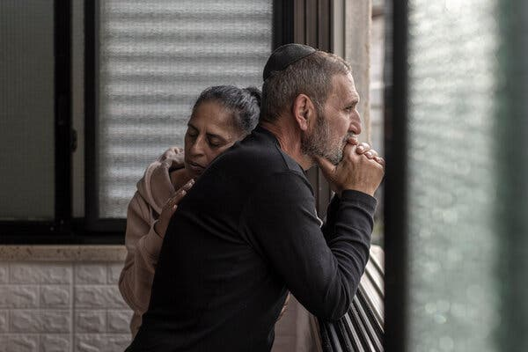

Ms. Abdush’s parents, Eti Bracha, 56, and her husband, Eli, 60.

[**Jeffrey Gettleman**](https://www.nytimes.com/by/jeffrey-gettleman) is an international correspondent and a winner of the Pulitzer Prize. He is the author of [“Love, Africa,”](https://www.jeffreygettleman.com/) a memoir. [More about Jeffrey Gettleman](https://www.nytimes.com/by/jeffrey-gettleman)